TE Getting Started:
- https://scanner_ip:1820
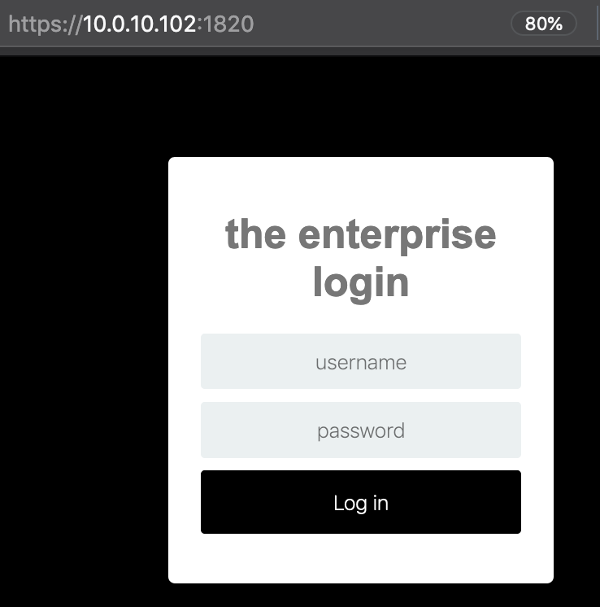
- Login using password from Enterprise LastPass
  - User: enterprise_user
  - Pass:s4Z8vhgRQmpAJYjZpP$qbJ!ZQi5&BhzF7vq#MA*MLW4GL%zn*y7ZvWnbGeWImHA7rTY2at3sEf3JZAWHGgGjdhY5rr
  - OR Create your own Flask User through python enterprise.py (log into scanner box, cd /pentest/py3virtual/the_enterprise, then do source ../activate/bin and then type “python enterprise.py”
  - In here, say Y to show profile and answer Y to the question of “View Flask Users at Login”
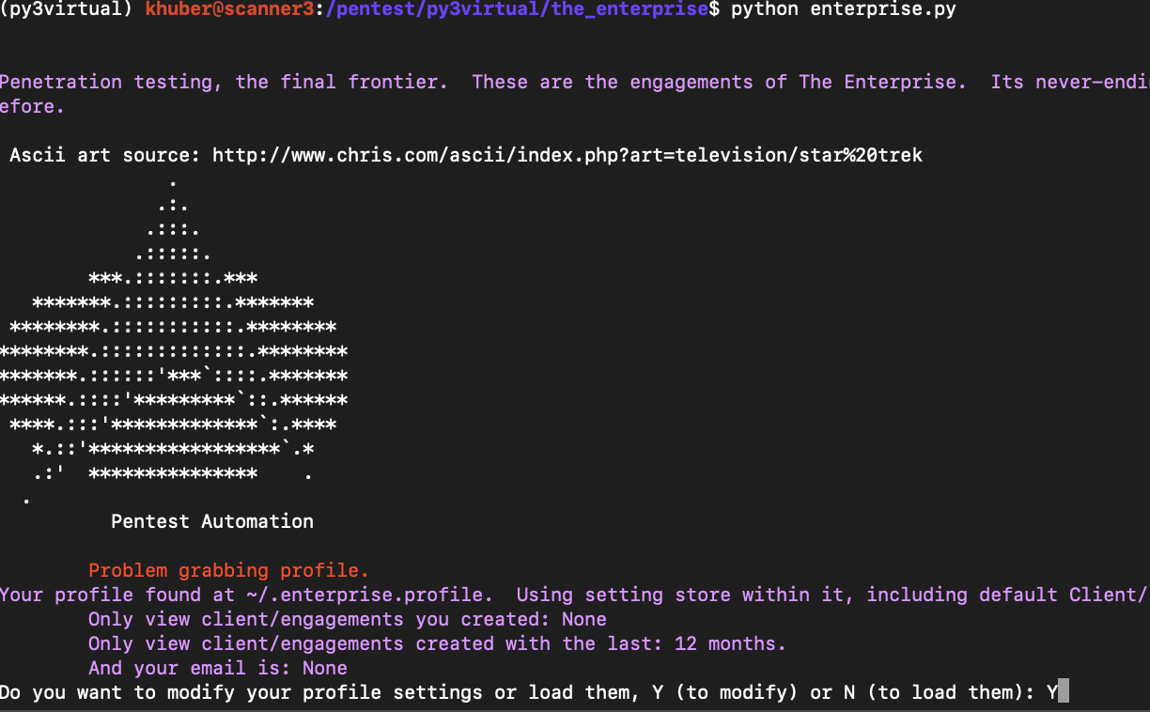

  - Now you should be able to view current flask users and create your own
    - Your password must be 20+ characters
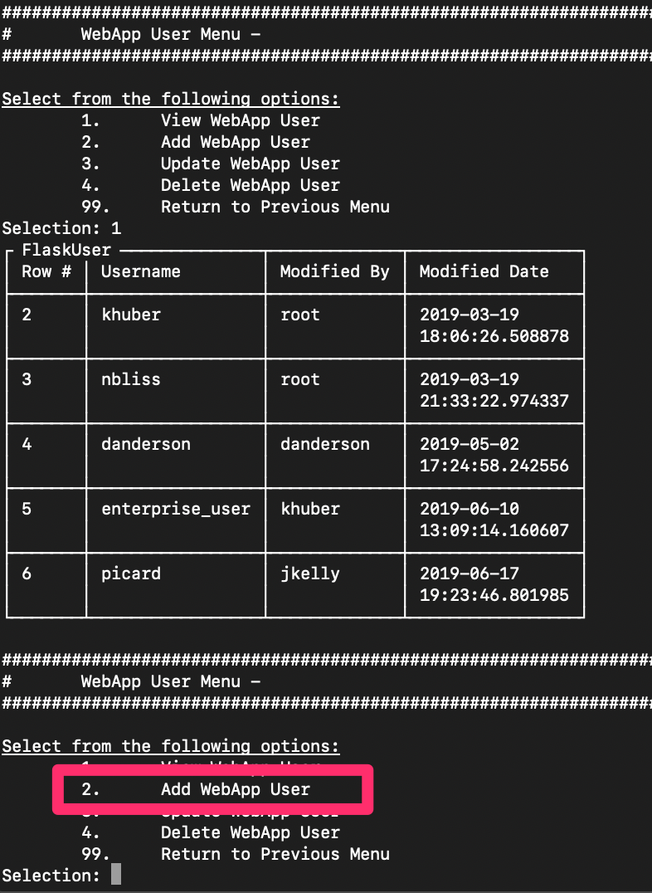
- Now create an engagement (can do it through web app or console – python enterprise.py)
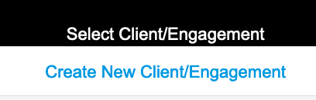
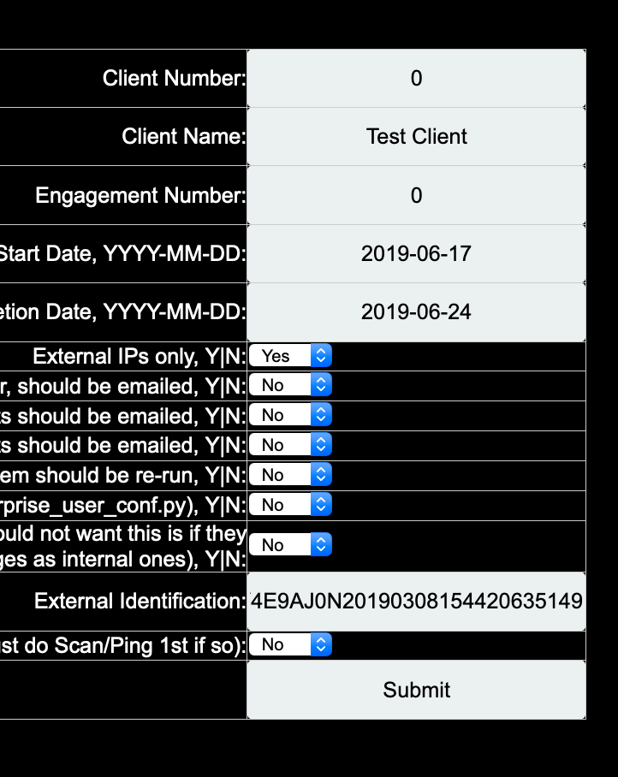
- External Identification is highly recommended filling out. You get that number from Engage (your engagement as represented in Engage as show in the images below). This External identification # will allow all email relay emails that are forwarded back to ‘relay@issgs.net’ to automatically be added to the correct engagement in Engage

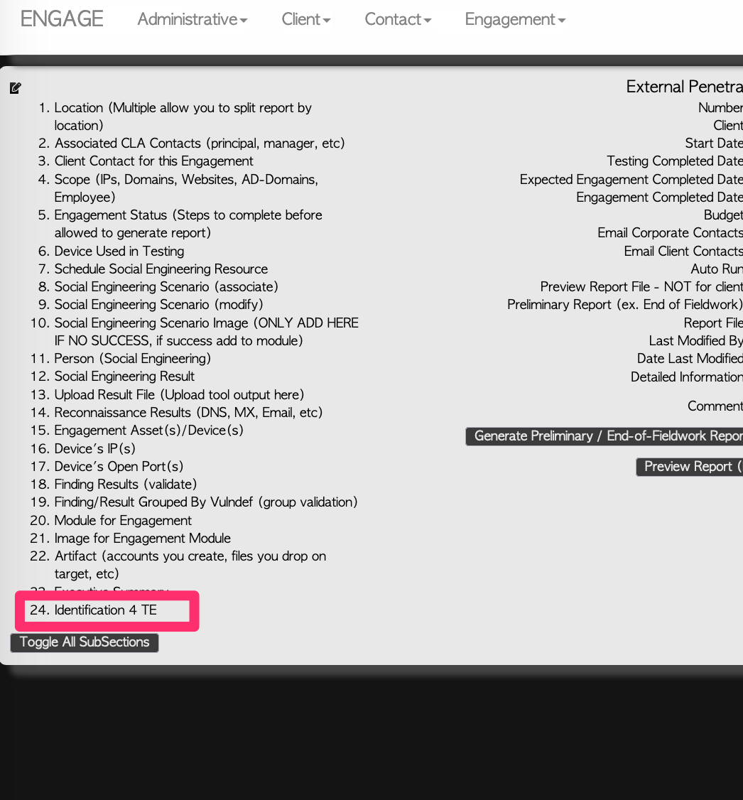
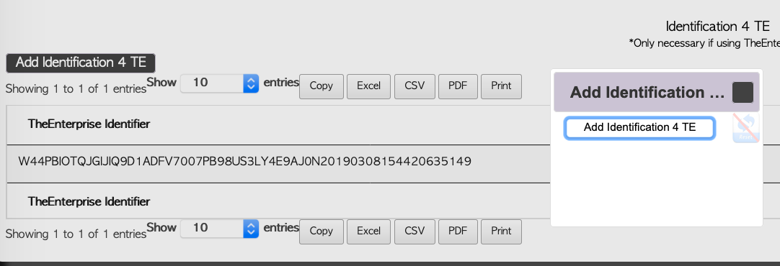
- Now Add your Scope and Client Contact under “Setup”
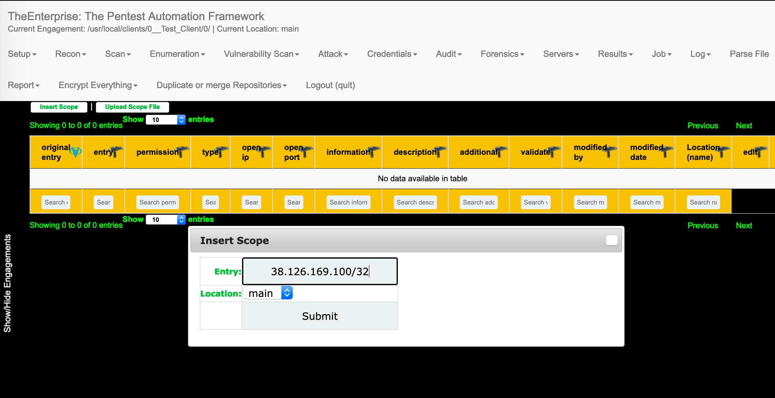
  - When all scope is added (ips, domains, and websites), you can kick off tools)
    - Typically start with Recon tools, then Scan
      - Nessus is found under Vulnerability Scan
    - Email Relay is found under Vulnerability Scan and should be run after Recon tools find MX records for domains and nmap-tcp default has run (in case smtp server open to Internet).
- Results can be found under the “Results” menu
- You can view running jobs (and kill them), by going to the “Job” menu.
- All your client files are saved at: /usr/local/clients/whatever_you_entered_for_the_client_number and client_name when setting up the engagement/whatever you entered for the engagement_number/
  - All output from tools are saved in the subfolder ‘output’ subfolder for the engagement
  - You can upload the .out file straight to Engage to pull all the results from TE to Engage
- Additional Info:
  - By default, tools will only run 1 time successfully against a given target
    - Ie. Nmap-tcp default scan for 1.1.1.1/32 will only run once
  - If the tool fails, then it can still be re-tried, or if you just want to re-try then you can go to Setup -> Engagement and change the “if tool already ran per scope item should be re-run to Y. Then when you re-run nmap-tcp default it will run against all Scope IPs even if successfully already run
